1. Login Form

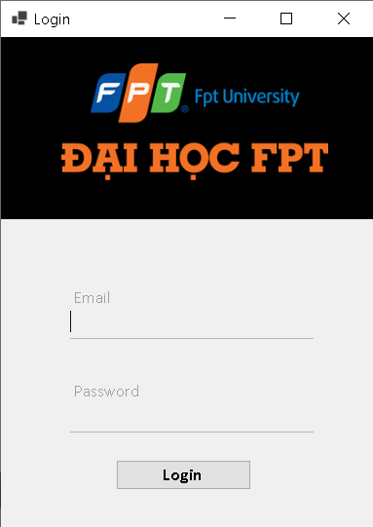

|  |  |  |  |
| --- | --- | --- | --- |
| No. | Object Type | Object Name | Properties/Events |
| 1 | panel | PnLogo | * Backcolor: Black * Size: 382, 190 * Dock: Top |
| 2 | panel | PnControlLogin | * Size: 382, 318 |
| 3 | PictureBox | ImgLogo | * BackColor: Black * Size: 320, 120 * SizeMode: Zoom |
| 4 | Label | LbEmail | * Text: Email * ForeColor: Control * Font: Calibri, 11, Regular |
| 5 | Label | LbPassword | * Text: Password * ForeColor: Control * Font: Calibri, 11, Regular |
| 6 | TextBox | TxtEmail | * Font: Calibri, 11, Regular * Size: 250, 22 * BackColor: Control |
| 7 | TextBox | TxtPassword | * Font: Calibri, 11, Regular * Size: 250, 22 * BackColor: Control * Font: Calibri, 11, Bold |
| 8 | Button | BtnLogin | * Text: Login * Size: 139, 31 * Event Handler: Click |
| 9 | Form | FrmLogin | * Size: 400, 550 * Text: Login * StartPosition: CenterScreen |